The Think BabiesTM Election Toolkit is designed to help advocates, like you, highlight issues facing infants, toddlers, and their families in the federal, state, and local elections, and educate the candidates on what babies and families need to thrive.
Elections bring into focus the priorities of voters across the country and help set the agenda for the next Congress and the next term for state and local policymakers. With 34 Senators, 435 Representatives in the House, 36 Governors, and thousands of state and local lawmakers up for election in 2022, advocates have countless opportunities to educate candidates and turn them into champions who will make the needs of families their priority. Once elected, these candidates will make critical decisions that impact families and, with the right focus, can help ensure that all infants and toddlers have what they need for a strong start in life. As people who are passionate about the youngest children and their families, we play a critical role by ensuring that all candidates have the information they need to make these decisions and by elevating the discussion of these issues among all candidates, the media, and voters. While many issues being discussed during the election cycle impact babies and families, this toolkit will focus on educating candidates on three key areas that are critical to families with infants and toddlers:
- Affordable, quality child care
- Paid family and medical leave
- Economic security supports like the Child Tax Credit

There are many ways you can leverage the tools here to call on 2022 candidates to Think Babies and make their potential a priority, including:
- Email candidates’ campaigns to provide them with resources as they make decisions about policy priorities.
- Engage candidates directly by participating in local and virtual events and asking questions about infant and toddler issues at candidate forums.
- Post on social media to ask candidates where they stand on the policies and investments that babies and families need.
- Submit a letter to the editor to your state and/or local media outlet, highlighting the policies and investments needed for young children in your community.
- Spread the word about the toolkit in your community through newsletters, blogs, social media, or via email and call on your community to amplify infant and toddler issues. Encourage others to join you to Be a Big Voice for Little Kids™.
- Vote.

While the resources in this toolkit are primarily aimed at the federal races, they can be modified based upon your state and local elections. To learn more about candidates running in state and local elections, visit NGA.org and USA.gov.
About Think Babies
ZERO TO THREE created Think Babies to bring attention to what babies and their families need to thrive. Think Babies is a call to action for policymakers to prioritize the needs of infants, toddlers, and their families and invest in our future. Learn more at www.thinkbabies.org. Learn more at www.thinkbabies.org.
As a 501(c)(3) charity, ZERO TO THREE does not support or oppose any candidate. Our mission is to educate the public and candidates about the issues that impact babies and toddlers.
Toolkit Contents
Strategies to Engage and Educate Candidates 2
In-Person & Virtual Events 3
Social Media 3
Email 3
Sample Email to Candidates and Their Campaigns 4
Sample Social Media Posts and Graphics 6
Sample Letter to the Editor 7
Questions for Candidates 8
Sample Opening Statement 9
Sample Questions 9
Sample Email to Winning Candidates 9

Strategies to Engage and Educate Candidates
The resources in this toolkit are designed to help you reach out to candidates to advocate on the issues that matter most to you. Whether it is in-person, at a virtual event, on social media, or through email, your engagement makes a difference. Feel free to adapt these materials to educate candidates in other state and local elections. Please reach out to educate all viable candidates for a given office. Your voice matters to the candidates running to represent you.

In-Person & Virtual Events
“Town hall” meetings or candidate forums with voters are a great venue to share your concerns with candidates. Federal candidates, as well as your state and local leaders, regularly hold these sessions throughout the campaign cycle, and they are often open to the public. They usually include a question-and-answer session – giving you the opportunity to share the Think Babies message and ask the candidates about infant-toddler issues.
- Find an event: Sign up for a candidate's listservs, newsletters, or social media account to get updates and check back to learn when they may be hosting public forums. You can also visit TownHallProject.com to find campaign town hall events for federal candidates on the ballot in 2022. Prepare: Once you have identified an event, prepare a brief statement or question beforehand. As you prep, be sure to review the Think Babies Election Toolkit sample questions and the Candidate Guide to Think Babies for more information on infant and toddler issues and stories from parents across the nation. You can also coordinate with other advocates in your community to make a stronger impact. Remember to practice what you want to say and be specific with questions. This toolkit also includes a worksheet to formulate your own questions to get you started. Always remember to pose open-ended questions.
- Follow up: Give the Candidate Guide to Think Babies in this toolkit to the candidate or staff members at in-person events and be sure to follow up with a digital version of the guide after in-person and virtual events. Staff are a critical link in educating candidates and elevating issues. After an event, you can email the candidate and their staff to reinforce your message and thank them for their time. Don’t forget to provide your contact information and remind them about your areas of expertise – they may want to follow up with you down the road!

Social Media
Use social media to share Think Babies messages and buzz about what babies and families need to thrive. Social media is a great way to directly connect with all candidates while also amplifying infant and toddler issues with your networks. This toolkit includes sample social media posts that you can use or adapt, as well as the social media profiles for each candidate. Remember to use the #ThinkBabies hashtag and tag @ZEROTOTHREE so we can amplify your posts.

Email
Use email to reach out to the campaigns directly and share information on the needs of babies and families. Use the sample email in the toolkit to get started, make sure to personalize your story and put a face to the challenges families experience as well as the benefits of supportive policies like paid family and medical leave, child care supports, and economic security supports like the Child Tax Credit. Some campaigns have specific email addresses you can use, others ask you to fill out a form on their website.

Sample Email to Candidates and Their Campaigns

As a [INSERT YOUR PROFESSIONAL TITLE, ORGANIZATIONAL EXPERTISE, OR PERSONAL CONNECTION TO ISSUE] from [INSERT CITY AND STATE], I am writing to you on behalf of infants, toddlers, and parents in [YOUR STATE].
The first three years of a child’s life shape all the rest. During this time, our brains grow faster than any later point in our lives. If elected, you will make decisions that impact the lives of infants and toddlers across the country, with effects now and in the future. Every parent wants to give their child a strong start in life, but our policies have not kept up with the reality of parenting today and the challenges that families with young children face.
Infants, toddlers, and their families need: affordable, quality child care; comprehensive paid family and medical leave; and economic security supports like the Child Tax Credit. These policies will help ensure that families in my community and across the country are able to provide their children with the opportunities they need to thrive. Comprehensive paid family and medical leave gives families crucial time to foster the early relationships that build strong brain connections and bond with their babies, as well as care for children with serious illnesses. Access to quality child care not only offers families a critical support for employment and education, but it also supports babies earliest learning laying the groundwork for future success, including strong cognitive skills, higher scores on math and language measures, and the social and emotional skills critical to all learning. Bolstering economic security means families of infants and toddlers have the resources to provide safe housing, nutritious foods, adequate clothing and diapers, and regular access to medical care so their young children have the stability they need to support their rapid growth and development.
Paid family and medical leave: Has robust (84 percent) support from voters. The emergency family and medical leave created during the pandemic was a temporary solution that demonstrated the potential of a national paid family and medical leave program to address the needs of both families and businesses. Unfortunately, our failure to enact a permanent policy means that families are once again left without solutions.
. Comprehensive paid family and medical leave embodies the following core principles:
- Accessibility for all working people;
- A meaningful length of leave — at least 12 weeks;
- Coverage for the full range of medical and family caregiving needs established in the Family and Medical Leave Act;
- Affordability and cost-effectiveness for workers, employers, and the government;
- Inclusivity in its definition of “family”; and
- Protections against employer retaliation when workers utilize their right to take leave.

Quality, affordable child care: Nearly 8 in 10 voters support increasing funding for quality, affordable early care and learning programs. Our frayed child care system is failing babies, families, providers, and our economy. Robust public funding is imperative for a system of high-quality programs and providers accessible to all families. Any policy solution must be built on principles that will ensure it serves the needs of the current and future workforce and economy:
- Quality: All children receive high-quality child care which includes responsive, consistent caregivers and a safe environment in which to explore and learn;
- Access: Families can access the high-quality child care setting that best meets their needs;
- Affordability: Families get the financial support they need to afford high-quality child care; and
- Workforce: Early childhood professionals in all settings and age groups can receive the support, resources, and compensation they need to provide high-quality care and support their own families.

Economic Security: Young children grow and learn in the context of their families and communities. Ensuring family and community-level economic security is fundamental to creating the environment in which young children thrive, laying the groundwork for our next generation. Poverty literally gets under the skin, undermining strong brain development and other physiological systems. The enhanced federal Child Tax Credit helped families with young children meet basic needs on a monthly basis (e.g., food, housing, utilities, and telecommunications). This was particularly true for families with low income of which 73% of families surveyed used the Child Tax Credit for these purposes. Families who were receiving Child Tax Credit payments were less likely during that time to report experiencing material hardship that can lead to toxic stress for babies than households that had not received the payments. Unfortunately, this vital support for families has been allowed to lapse, increasing the risks for families of economic insecurity. Policymakers can help build an economic system that would ensure families have enough income to make ends meet and nurture their children by:
- Permanently reinstating the enhanced, fully refundable federal Child Tax Credit which expired at the end of 2021;
- Ensuring a federal and state minimum wage of $15/hour;
- Increasing the federal and state Earned Income Tax Credit; and
- Helping close the wealth gap with “Baby Bonds”.
These policy solutions address the real needs of working families across our country. Each infant and toddler is born with unlimited potential. Together, they are our society’s next generation of parents, workers, and leaders. We can’t afford to squander the potential of a single child if our nation is to thrive. The future begins now, with babies.
To learn more about what babies and families need to thrive, visit https://bit.ly/TBCandidateGuide .
Thank you.
[NAME]

Sample Social Media Posts and Graphics
Share Think Babies messages through these social media posts to create a steady drumbeat and generate buzz about what babies and families need to thrive. Below are sample posts that you can use or adapt. Remember to use the #ThinkBabies hashtag and tag @ZEROTOTHREE so we can amplify your posts.
Amplify – Call on your community to Think Babies in the elections
- Our elected officials make critical decisions that impact families and can help ensure that all infants and toddlers have what they need for a strong start in life. Help make sure candidates have all the information they need: https://bit.ly/TBVoterGuide #ThinkBabies
- The greatest opportunity to influence a child’s success begins early when our brains grow faster than any later point in life. Get the tools and resources you need to urge candidates to #ThinkBabies: https://bit.ly/TBCandidateGuide
- Whether at a local townhall, during a debate, or on social media, each of us can educate all candidates to turn them into champions for infants and toddlers and their families. https://bit.ly/TBVoterGuide #ThinkBabies
- As infant and toddler advocates, we play a critical role by ensuring that all candidates have the information they need to make crucial decisions that will impact families. Join in the momentum: https://bit.ly/JoinThinkBabies #ThinkBabies
Educate – Inform candidates on how to Think Babies in the election and beyond
- Families like mine need #paidleave, #childcare, and the #ChildTaxCredit to build a strong foundation for our infants and toddlers. It’s time to #ThinkBabies in #Midterms2022 and make their potential our priority. [INSERT CANDIDATES’ HANDLES] https://bit.ly/TBCandidateGuide
- As a [INSERT PROFESSIONAL TITLE, ORGANIZATIONAL EXPERTISE, OR PERSONAL CONNECTION TO ISSUE], I know the importance of investing in the early years for children and families. If elected, how would you #ThinkBabies? https://bit.ly/TBCandidateGuide [INSERT CANDIDATES’ HANDLES]
- #Midterms2022 brings into focus voters’ priorities and sets the agenda for Congress and policymakers across the country. Will infants and toddlers and their families be at the top of your list? #ThinkBabies https://bit.ly/TBCandidateGuide [INSERT CANDIDATES HANDLES]

Download the social media graphics to post with the content above.

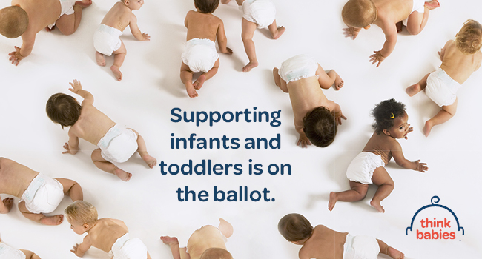  DOWNLOAD THIS GRAPHIC  --Twitter  --Facebook/Instagram: Posts and Stories | 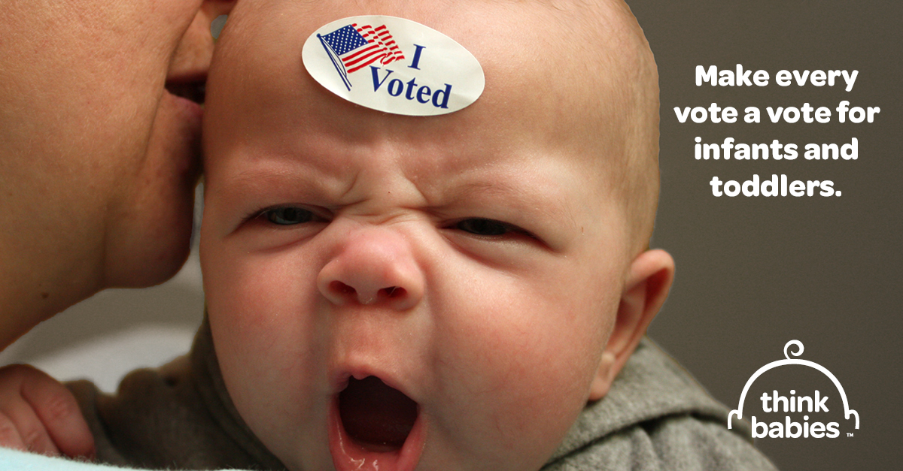  DOWNLOAD THIS GRAPHIC  --Twitter  --Facebook/Instagram: Posts and Stories
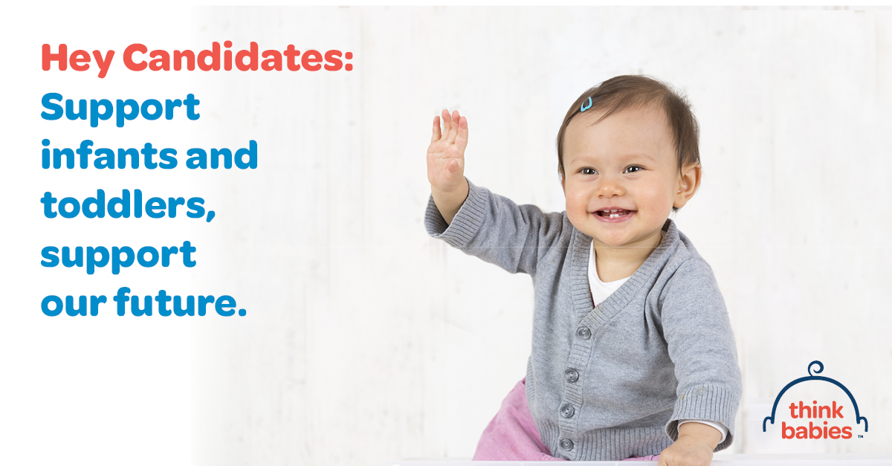  DOWNLOAD THIS GRAPHIC  --Twitter  --Facebook/Instagram: Posts and Stories | 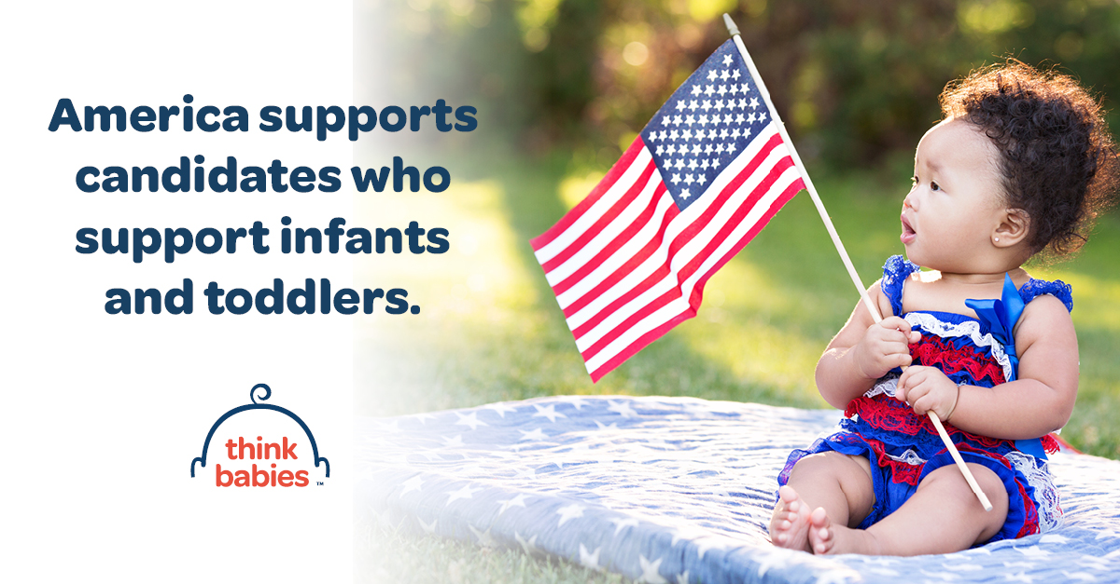  DOWNLOAD THIS GRAPHIC  --Twitter  --Facebook/Instagram: Posts and Stories

Sample Letter to the Editor
For tips on how to write a letter to the editor, click here.
The [INSERT DATE] article [“INSERT ARTICLE HEADLINE”] addressed [INSERT RELATED TOPIC]. Of all the issues getting attention during the election cycle, the science tells us what must rise to the top. The greatest opportunity to influence a child’s success begins at the earliest years of life when our brains grow faster than any later point.
This year, the election will bring into focus the priorities of voters, like myself, and help set the agenda for the next Congress, and the next term for other policymakers on the ballot. These elected officials will make critical decisions that impact families now and in the future, and can help ensure that all infants and toddlers have what they need for a strong start in life.
As a [INSERT YOUR ORGANIZATIONAL EXPERTISE, OR PERSONAL CONNECTION TO ISSUE], I am calling on candidates running in the 2022 midterm election to share their plans to address the big challenges that the littlest among us face, including access to quality, affordable child care; paid leave; and economic security supports like the child Tax Credit. By doing so, they can ensure that all infants and toddlers and their families have what they need to thrive and set our country on the path to a strong future.
Sincerely,
[NAME]
[TITLE]

Questions for Candidates

Sample Opening Statement
“My name is [NAME] and I am [INSERT YOUR PROFESSIONAL TITLE, ORGANIZATIONAL EXPERTISE, OR PERSONAL CONNECTION TO ISSUE] in our community. My hope is that when you think about the future of [STATE], you think of families with infants and toddlers – because when babies thrive, we all benefit. My question for you is. . .”

Sample Questions
- How would you address families’ need to access quality, affordable child care?
- How would you address ensuring families have time to bond with their babies in the earliest months when so much of their development is at stake?
- How would you address ensuring families have the time they need to take care of a child or other family member in the event of a serious illness?
- How would you ensure all families have the resources needed to provide safe housing, nutritious foods, adequate clothing and diapers, and regular access to medical care for their young children?

Formulating a Question
To ask the most powerful question you can that will elicit an equally powerful response, it is important to create and practice your question before an event. Use this worksheet to create your own message-based question to use at an event.
- Start with an introduction.
Give the candidate a simple introduction. This is as easy as stating your name and one other fact, such as why you are attending the event.
Hi, my name is ______________________ and I am here for ____________________________.
- Give a short story.
Giving a short story helps the candidate connect the question back to real life situations and gives more power to the question. Write a quick two or three sentences to tell a story related to the issue you would like to ask about.
________________________________________________________________________________________________________________________________________________________________________________________________________________
- Tie in the issue.
Give a follow up to your story that connects your personal story to a particular policy issue. Again, this doesn’t need to be long, just a sentence or two.
________________________________________________________________________________________________________________________________________________________________________________________________________________
- Hard ask.
This is where you flat out ask the candidate what they would do to help solve your problem. Do not offer them a solution, just ask the most basic question about the issue that you can and let them elaborate on it in their answer.
________________________________________________________________________________________________________________________________________________________________________________________________________________
- Put it all together to finalize your opening statement and question.
________________________________________________________________________________________________________________________________________________________________________________________________________________________________________________________________________________________________________________________________________________________________________________________________________________________________

Sample Email to Winning Candidates
After the election, it is important to follow-up with winners as they transition from campaigning to lawmaking. Remind the winning candidate and their incoming staff to Think Babies as they lay out priorities for their term. It is important for advocates to keep the momentum going through continuous education and amplification of issues that matter to you, the constituent, and babies in your community.
Congratulations on your success in the election.
As a [INSERT YOUR PROFESSIONAL TITLE, ORGANIZATIONAL EXPERTISE, OR PERSONAL CONNECTION TO ISSUE] from [INSERT CITY AND STATE], I urge you to prioritize the needs of infants, toddlers, and their families as you prepare for your term.
The science is clear. Babies’ brains develop faster from birth to age three than at any other time of life. Their early experiences – both positive and negative – build the foundation for brain architecture and physical and mental health that will support their ability to learn, grow and thrive. When babies and toddlers have resources and opportunities that support good health, strong families, and positive early learning experiences, it will lead to communities that are stronger, smarter, healthier, and fairer. Every child deserves a strong start life but opportunities to grow and flourish are not shared equally by all infants, toddlers, and families, reflecting past and present systemic racism and barriers to critical resources. Public policy has not kept up to meet the needs of today’s parents and caregivers. Even before the COVID-19 pandemic, just over 40 percent of babies lived in families without enough income to make ends meet. If our nation is to thrive, we must build for the future and ensure that every baby has what they need to reach their full potential.
- Paid family and medical leave: Has robust (84 percent) support from voters. The emergency family and medical leave created through the Families First Coronavirus Response Act was a temporary solution that demonstrated the potential of a national paid family and medical leave program to address the needs of both families and businesses. Unfortunately, our failure to enact a permanent policy means that families are once again left without solutions.

Comprehensive paid family and medical leave embodies the following core principles:
  - Accessibility for all working people;
  - A meaningful length of leave — at least 12 weeks;
  - Coverage for the full range of medical and family caregiving needs established in the Family and Medical Leave Act;
  - Affordability and cost-effectiveness for workers, employers, and the government;
  - Inclusivity in its definition of “family”; and
  - Protections against employer retaliation when workers utilize their right to take leave.

- Quality, affordable child care: Nearly 8 in 10 voters support increasing funding for quality, affordable early care and learning programs. Our child care system is failing babies, families, providers, and our economy. Robust public funding is imperative for a system of high-quality programs and providers that is accessible to all families. Any policy solution must be built on principles that will ensure it serves the needs of the current and future workforce and economy:
  - Quality: All children receive high-quality child care which includes responsive, consistent caregivers and a safe environment in which to explore and learn;
  - Access: Families can access the high-quality child care setting that best meets their needs;
  - Affordability: Families get the financial support they need to afford high-quality child care; and
  - Workforce: Early childhood professionals in all settings and age groups can receive the support, resources, and compensation they need to provide high-quality care and support their own families.
- Economic Security: Young children grow and learn in the context of their families and communities. Ensuring family and community level economic security is fundamental to creating the environment in which young children thrive, laying the groundwork for our next generation. Poverty literally gets under the skin, undermining strong brain development and other physiological systems. The enhanced federal Child Tax Credit helped families with young children meet basic needs on a monthly basis (e.g., food, housing, utilities, and telecommunications). This was particularly true from families with low incomes of which 73% of families surveyed used the Child Tax Credit for these purposes. Families who were receiving Child Tax Credit payments were less likely during that time to report experiencing material hardship than households that had not received the payments. Unfortunately, this vital support for families has been allowed to lapse, increasing the risks for families of economic insecurity. Policymakers can help build an economic system that would ensure families have enough income to make ends meet and nurture their children by:
  - Permanently reinstating the enhanced, fully refundable federal Child Tax Credit which expired at the end of 2021;
  - Ensuring a federal and state minimum wage of $15/hour;
  - Increasing the federal and state Earned Income Tax Credit; and
  - Helping close the wealth gap with “Baby Bonds”.
These policy solutions address the real needs of working families across our country. Each infant and toddler is born with unlimited potential. Together, they are our society’s next generation of parents, workers, and leaders. We can’t afford to squander the potential of a single child if our nation is to thrive. The future begins now, with babies. Congratulations again on your election. I look forward to working with you and your staff to ensure that all infants and toddlers have what they need for a strong start in life.
[NAME]

