Share Think Babies messages through these social media posts to create a steady drumbeat and generate buzz about what babies and families need to thrive. Below are sample posts that you can use or adapt. Remember to use the #ThinkBabies hashtag and tag @ZEROTOTHREE so we can amplify your posts.
Amplify – Call on your community to Think Babies in the elections
- Our elected officials make critical decisions that impact families and can help ensure that all infants and toddlers have what they need for a strong start in life. Help make sure candidates have all the information they need: https://bit.ly/TBVoterGuide #ThinkBabies
- The greatest opportunity to influence a child’s success begins early when our brains grow faster than any later point in life. Get the tools and resources you need to urge candidates to #ThinkBabies: https://bit.ly/TBCandidateGuide
- Whether at a local townhall, during a debate, or on social media, each of us can educate all candidates to turn them into champions for infants and toddlers and their families. https://bit.ly/TBVoterGuide #ThinkBabies
- As infant and toddler advocates, we play a critical role by ensuring that all candidates have the information they need to make crucial decisions that will impact families. Join in the momentum: https://bit.ly/JoinThinkBabies #ThinkBabies
Educate – Inform candidates on how to Think Babies in the election and beyond
- Families like mine need #paidleave, #childcare, and the #ChildTaxCredit to build a strong foundation for our infants and toddlers. It’s time to #ThinkBabies in #Midterms2022 and make their potential our priority. [INSERT CANDIDATES’ HANDLES] https://bit.ly/TBCandidateGuide
- As a [INSERT PROFESSIONAL TITLE, ORGANIZATIONAL EXPERTISE, OR PERSONAL CONNECTION TO ISSUE], I know the importance of investing in the early years for children and families. If elected, how would you #ThinkBabies? https://bit.ly/TBCandidateGuide [INSERT CANDIDATES’ HANDLES]
- #Midterms2022 brings into focus voters’ priorities and sets the agenda for Congress and policymakers across the country. Will infants and toddlers and their families be at the top of your list? #ThinkBabies https://bit.ly/TBCandidateGuide [INSERT CANDIDATES HANDLES]

Download the social media graphics to post with the content above.

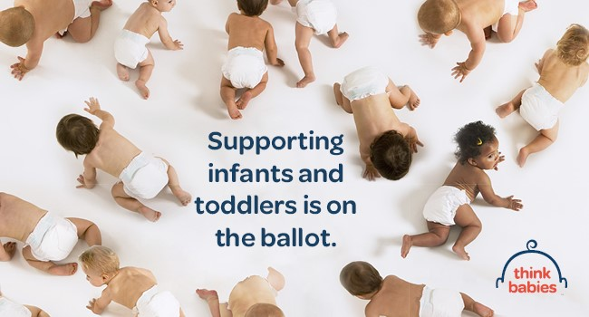  DOWNLOAD THIS GRAPHIC  --Twitter  --Facebook/Instagram: Posts and Stories | 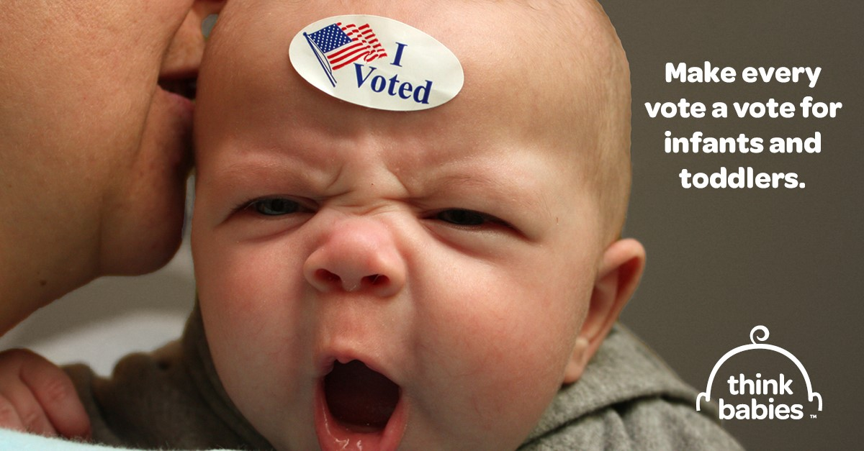  DOWNLOAD THIS GRAPHIC  --Twitter  --Facebook/Instagram: Posts and Stories
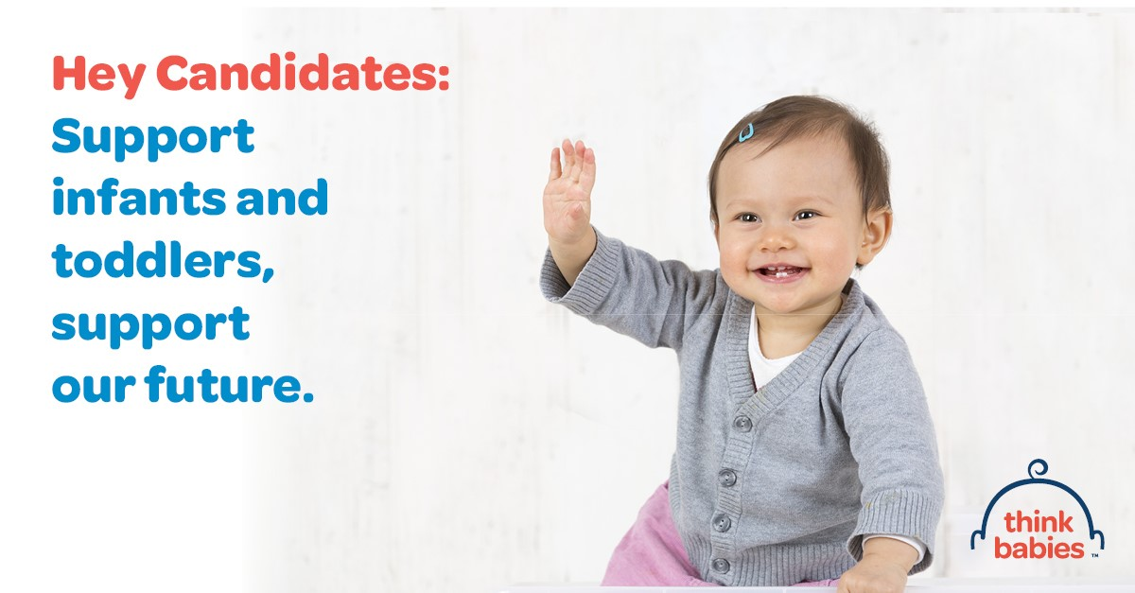  DOWNLOAD THIS GRAPHIC  --Twitter  --Facebook/Instagram: Posts and Stories | 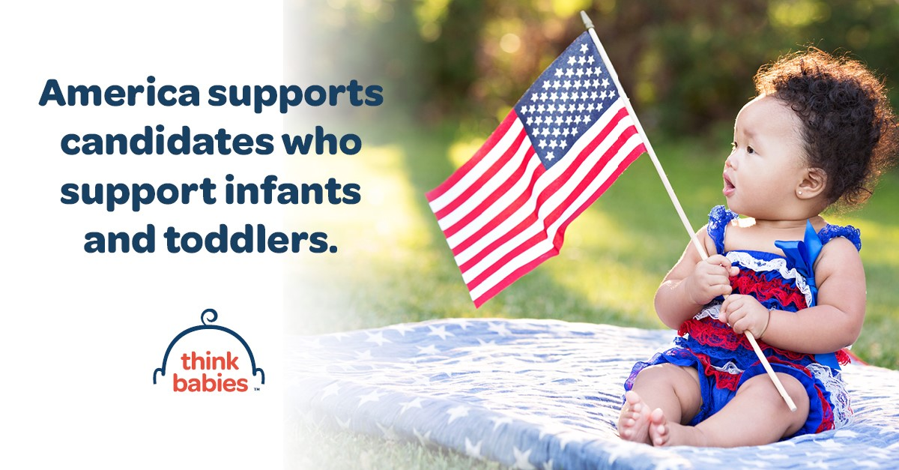  DOWNLOAD THIS GRAPHIC  --Twitter  --Facebook/Instagram: Posts and Stories

