Want to build a better future? It begins with infants and toddlers.

The science is clear. Babies’ brains develop faster from birth to age three than at any other time of life. Their early experiences – both positive and negative – build the foundation for brain architecture and physical and mental health that will support their ability to learn, grow, and thrive. When babies and toddlers have resources and opportunities that support good health, strong families, and positive early learning experiences, it will lead to communities that are stronger, smarter, healthier, and fairer.

Every child deserves a strong start in life but opportunities to grow and flourish are not shared equally by all infants, toddlers, and families, reflecting past and present systemic racism and barriers to critical resources. Public policy has not kept up to meet the needs of today’s parents and caregivers. Even before the COVID-19 pandemic, just over 40% of babies lived in families without enough income to make ends meet. If our nation is to thrive, we must build for the future and ensure that every baby has what they need to reach their full potential.

As a voter, you have the power to educate and elect candidates who are committed to making the potential of every infant and toddler our national priority.

In this voter guide you will find the information and policy solutions you need to Think Babies™ and vote. While many issues being discussed during the election cycle impact babies and families, this voter guide focuses on three key areas that are critical to families with infants and toddlers:
- Affordable, quality child care;
- Paid family and medical leave;
- Economic security supports like the Child Tax Credit.

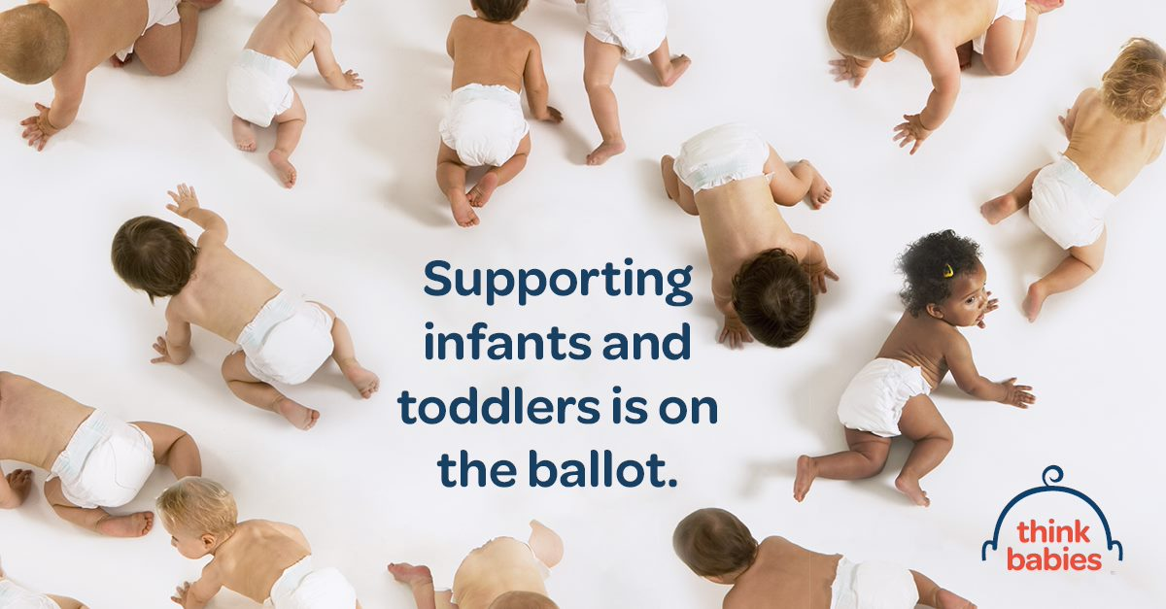
Infants and Toddlers in [State] Need Adults to Vote

With the Senate, House of Representatives, Governor, and numerous other state and local lawmakers up for election this year in [State], voters – like you! – have countless opportunities to evaluate and elect candidates who will make the needs of infants and toddlers their priority. Below are resources on how you can prepare to show up for infants and toddlers at the ballot box:

- Confirm Your Voter Registration
You can verify your voter registration by visiting headcount.org and entering some basic information. Follow the necessary steps for your state if you aren’t already registered or make any necessary changes prior to your state’s deadline. In [State], the deadline to register to vote in the November election is on [insert date].

- Research the Candidates and Issues on Your Ballot
Today’s candidate could be tomorrow’s baby champion. Visit ballotready.org or ballotpedia.org to:
- See every candidate and referendum that will be on your personal ballot;
- Learn about the candidates’ background and stances on the issues; and
- Make informed decisions about who and what you will vote for.

- Remember Key Voting Dates and Deadlines in [State]
- Voting by mail: You will receive your ballot in the mail. Completed ballots must be postmarked or dropped off at the designated drop-off location by [insert date]. [Insert any other relevant information such as how to find drop-off locations, how to request a mail in ballot, etc.]
- Voting in-person: Early voting starts on [insert date] and ends on [insert date]. You can also vote on election day, Tuesday, November 8. [Insert any other relevant information such as how to find a polling location, what to bring, etc.]
- For more information on where to vote, how to vote, how to vote early, and how to vote by mail, look up your state on headcount.org.

- Make a Plan to Vote and Encourage Families You Know to do the Same
Having a plan for how and when you’ll cast your ballot can help make sure you’re ready to vote in this year’s election. Use the prompts on the next page to create a plan for yourself and then share this resource with families you know so they can do the same. Print out your plan and put it somewhere visible to serve as a reminder!

My Voting Plan is:
I’ll vote by (circle one)
Early voting
Absentee or mail-in voting
In-Person voting

I’ll cast my vote on _____________________
(date)
At this time (check one)
[ ] Before work/school
[ ] After dropping my kids off at school/child care
[ ] During my lunch break
[ ] After Dinner
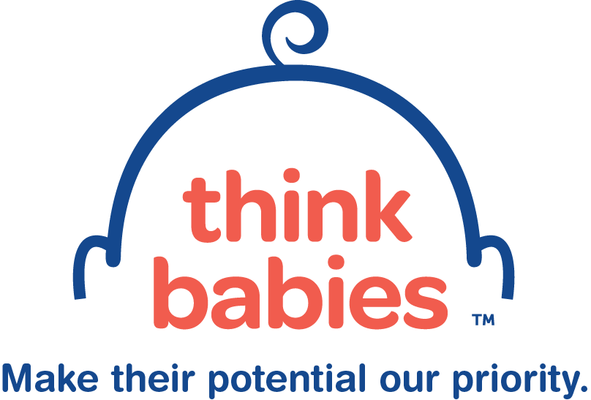
[ ] Other: ______________________
[ ] I’m voting by mail – I will complete and drop of my ballot on ____________________
(date)

The person who will care for my children when I vote is: __________________

Infants and Toddlers Need Comprehensive Paid Family and Medical Leave
The time after the birth or adoption of a baby is an essential time of development for babies and families.

Because early relationships nurture brain connections that form the foundation for learning and relationships, parents and caregivers play the most important role in supporting their children’s healthy development. When families have the supports and resources that they need and want, outcomes for babies improve.

Eighty five percent of working people in the United States do not have access to paid leave through their employers (U.S. Bureau of Labor Statistics). That means many parents must make the impossible choice between taking the time they need to bond with and care for their babies and losing their jobs or economic security.

The COVID-19 pandemic has brought our country’s caregiving crisis to the forefront of national discourse. Paid family and medical leave is essential for supporting family’s economic stability in the face of unforeseen circumstances. Families’ experiences of the public health crisis demonstrated that our lack of a national paid family and medical leave program is dangerous.

Families need more than the emergency paid leave provisions passed by Congress in the Families First Coronavirus Response Act which has since expired. As of summer 2022, only 10 states and the District of Columbia have passed paid leave laws or ballot initiatives. Babies and their families need a permanent, comprehensive national paid family and medical leave program that gives them time to bond with their babies, foster nurturing relationships that build early brain connections, and care for themselves or family members with serious illnesses.

Policymakers must invest in comprehensive paid family and medical leave insurance programs that embodies the following core principles:
- Accessibility for all working people;
- At least 12 weeks of leave;
- Coverage for the full range of medical and family caregiving needs established in the Family and Medical Leave Act;
- Affordability and cost-effectiveness for workers, employers and the government;
- Inclusivity in its definition of “family”; and
- Protections against employer retaliation when workers utilize their right to take leave.

For more information, visit thinkbabies.org/policy-priorities-paid-leave.

Infants and Toddlers Need Quality, Affordable Child Care
Quality child care prepares babies for future learning and success.

Parents and primary caregivers play the most immediate role in shaping their children’s early foundation. When parents go to work, school, or job training however, they need access to high-quality, affordable child care that supports their infants’ and toddlers’ healthy development. Access to quality child care not only supports families’ employment and education, it also lays the groundwork for babies’ future success, including strong cognitive skills, higher scores on math and language measures, and the social and emotional skills critical to all learning. Unfortunately, high-quality child care can be hard to access, especially for families with low incomes.

Infant-toddler care, especially high-quality care, is prohibitively expensive with costs ranging from 29.3% of a family’s income to 93.8% depending on where the family lives. Infant-toddler care costs more than in-state college tuition in 35 states and the District of Columbia and surpasses the cost of housing in 3 out of 4 regions. Despite the high cost of care, few families receive financial assistance for it. Only 4.6% of infants and toddlers in families with low-or moderate-incomes are served by the Child Care and Development Fund. Individual states set eligibility levels for child care subsidies. Only 16 states allow child care subsidies for families with incomes above 200 percent of the federal poverty level which was $46,060 a year for a family of three in 2022.

This country’s child care system was broken before COVID-19. The pandemic has further strained the system. Inadequate public investment has produced a system where the families who can find infant-toddler child care pay more than they can afford. Many are forced to leave the workforce altogether to become full-time caregivers. Child care providers, many of them women of color, earn too little, threatening the ability of child care programs to operate and the ability of individual staff to provide for their own needs and those of their families. In this environment, far too many young children do not receive the stable, nurturing care that they need to thrive.

Families have faced an increased lack of access to reliable child care throughout the pandemic, from early widespread closures to ongoing intermittent closures following outbreaks and exposures. This lack of access and unpredictability has directly impacted parents’, particularly mothers’, workforce participation, threatening family economic security and our country’s economy.

Our child care system is failing babies, families, and providers. Robust public funding is imperative for a system of high-quality programs that is accessible to all families. Any policy solution must be built on principles that ensure:
- All children receive quality child care with responsive, consistent caregivers and a safe environment in which to explore and learn;
- Families can access the high-quality child care setting that best meets their needs;
- Families get the financial support they need to afford high-quality child care; and
- Early childhood professionals in all settings and age groups receive support, resources, and compensation to provide high-quality care and support their own families.

For more information, visit thinkbabies.org/policy-priorities-child-care.

Infants and Toddlers Need Economic Stability
For the almost 4 million babies born each year in the United States, economic security can mean the difference between a strong beginning and a fragile start.

Ensuring economic security for families and communities is fundamental to creating the environment in which young children thrive, laying the groundwork for our next generation. Poverty gets under the skin, undermining strong brain development and other physiological systems. More than 80% of children in families with low incomes live in a household where at least one person is employed but work alone is often not enough to lift a family out of poverty or help them reach economic security. A parent or caregiver working full-time at the federal minimum wage will have only $15,080 in annual income. That is not enough to lift even a 2-person family out of poverty. Even before the COVID-19 pandemic, nearly 1 in 5 babies lived in poverty. Poverty among American Indian/Alaska Native and Black infants and toddlers is nearly twice the national average, affecting more than 1 in 3 babies. Hispanic infants and toddlers are more likely to live in poverty than the national average, with 1 in 4 babies in poverty. These disparities are rooted in structural racism and discriminatory policies that have historically blocked opportunity for these communities. The chronic, unrelenting stress and instability associated with poverty is compounded by difficulty accessing services such as preventative health care, quality housing, treatment for physical and mental health challenges, and quality child care or finding employment that provides paid family and medical leave.

We can ensure families can provide safe housing, nutritious foods, adequate clothing and diapers, and regular access to medical care so young children have stability during this time of rapid growth and development. The enhanced, monthly federal Child Tax Credit supported families with young children in meeting basic needs (e.g., food, housing, utilities, and telecommunications). Seventy three percent of families with low income reported using the Child Tax Credit for these purposes. Families who received Child Tax Credit payments were less likely during that time to report experiencing material hardship than households that had not received the payments. Unfortunately, Congress allowed this vital support for families to lapse, increasing the risks for families of living in economic insecurity.

Every parent wants to give their child a strong start in life. Policymakers can help build an economy that would ensure families have enough income to make ends meet and provide for their children’s healthy development by:
- Making permanent the enhanced, fully refundable federal Child Tax Credit for young children which expired at the end of 2021;
- Ensuring a federal and state minimum wage of $15/hour;
- Increasing the federal and state Earned Income Tax Credit; and
- Helping close the wealth gap with “Baby Bonds”.

For more information, visit https://www.thinkbabies.org/policy-priorities-economic-security.

